## **1. WEBSITE DETAILS**

**Title of the Website:**Semantic and Multimedia Webpage Using HTML5

**Purpose of the Website:**The purpose of this website is to demonstrate the use of **HTML5 semantic elements**, **proper document structure**, and **multimedia integration** using audio and video tags.

**Target Users:**

* Students
* Beginners in Web Development
* Educational Institutions

**Tools Used:**

* HTML5
* Text Editor: NeoVim
* Web Browser: Firefox

**Key Features:**

* Semantic HTML structure
* SEO-friendly meta tags
* Accessible content layout
* Embedded audio and video with controls and captions

## 

## 

## 

## **2. TAG DEFINITIONS USED IN THE WEBPAGE**

### **2.1 Basic Structure Tags**

| Tag | Definition |
| --- | --- |
| <!DOCTYPE html> | Declares the document type and version of HTML (HTML5) to the browser. |
| <html> | The root element of the HTML page that contains all other elements. |
| <head> | Contains meta-information about the document, such as title, character set, and linked styles, which is not displayed on the page. |
| <title> | Specifies the title of the webpage, which appears in the browser’s title bar or tab. |
| <meta> | Provides metadata about the HTML document, such as character set, viewport settings for responsiveness, and descriptions for SEO. |
| <link> | Defines the relationship between the current document and an external resource (used here to link the CSS file). |
| <body> | Contains all the visible content of the webpage, such as headings, paragraphs, images, and lists. |
| <div> | A generic container used to group content together for styling or layout purposes. |

### **2.2 Semantic Tags**

| Tag | Definition |
| --- | --- |
| <header> | Represents introductory content, typically containing a group of introductory aids or navigational aids. |
| <nav> | Defines a section of the page intended for navigation links. |
| <main> | Specifies the main content of the document, which should be unique to that document. |
| <section> | Defines a thematic grouping of content, typically with a heading. |
| <article> | Represents a self-contained composition in a document, page, application, or site, which is intended to be independently distributable or reusable. |
| <aside> | Defines content aside from the page content (like a sidebar), which is indirectly related to the surrounding content. |
| <footer> | Defines a footer for a document or section, often containing copyright information or authorship. |

### 

### 

### **2.3 Multimedia Tags**

| Tag | Definition |
| --- | --- |
| <img> | Embeds an image into the document. |
| <audio> | Used to embed sound content in a document, such as music or other audio streams. |
| <video> | Used to embed video content in a document, such as a movie clip or other video streams. |
| <source> | Specifies multiple media resources for media elements, such as <video> and <audio>. |
| <track> | Specifies text tracks (like subtitles or captions) for media elements (<audio> and <video>). |

## **3. SCREENSHOTS**

*(Attach screenshots of the output here)*

### **Suggested Screenshots:**

1. **Full Webpage View**
2. **Header and Navigation Section**
3. **Semantic Content Section**
4. **Audio Player Output**
5. **Video Player with Captions**

*Note:* Screenshots should clearly show the webpage output and must be properly labeled.

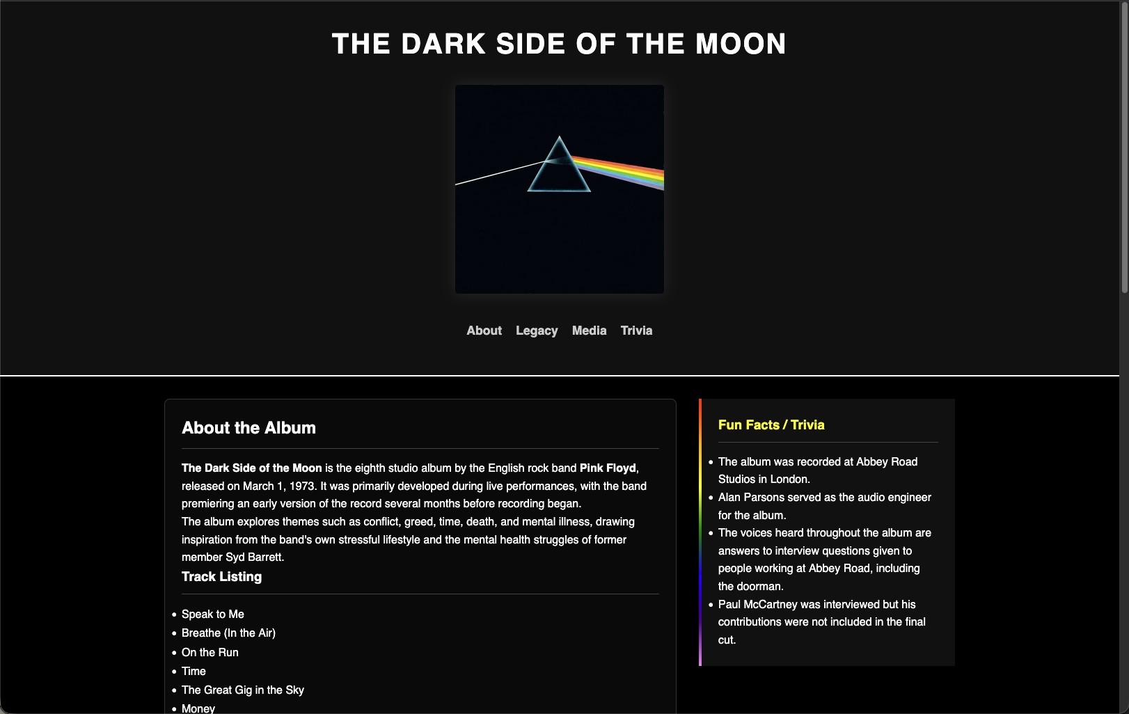

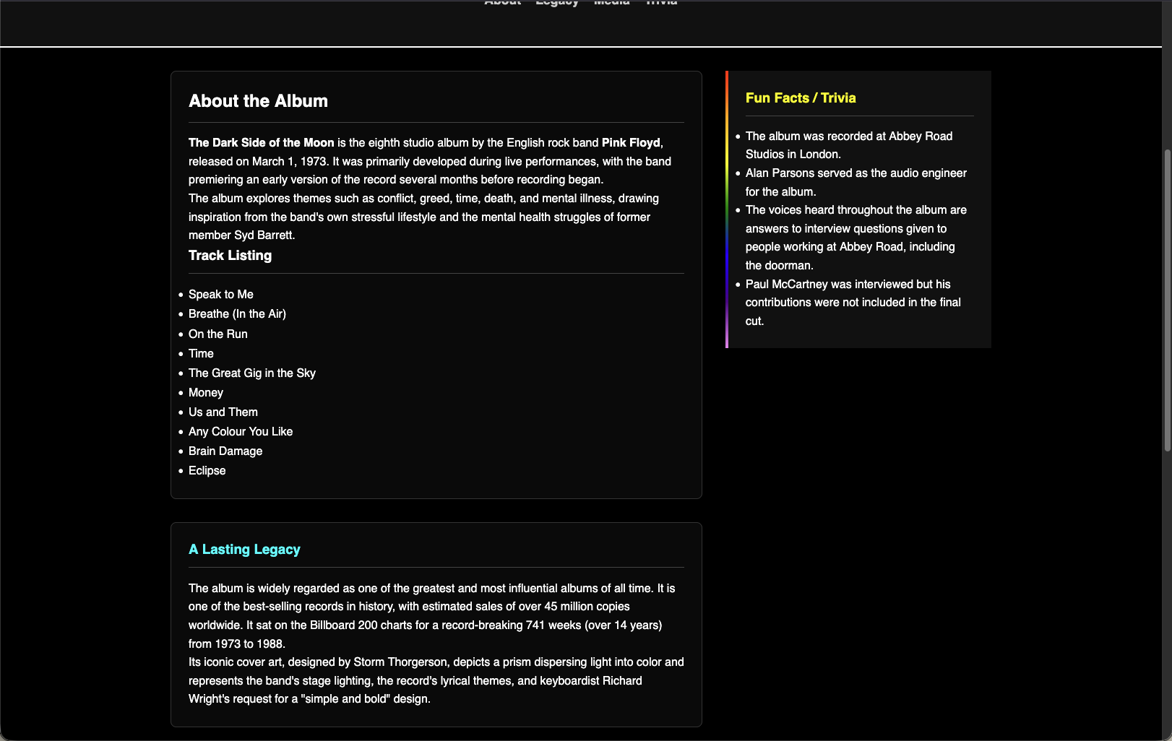

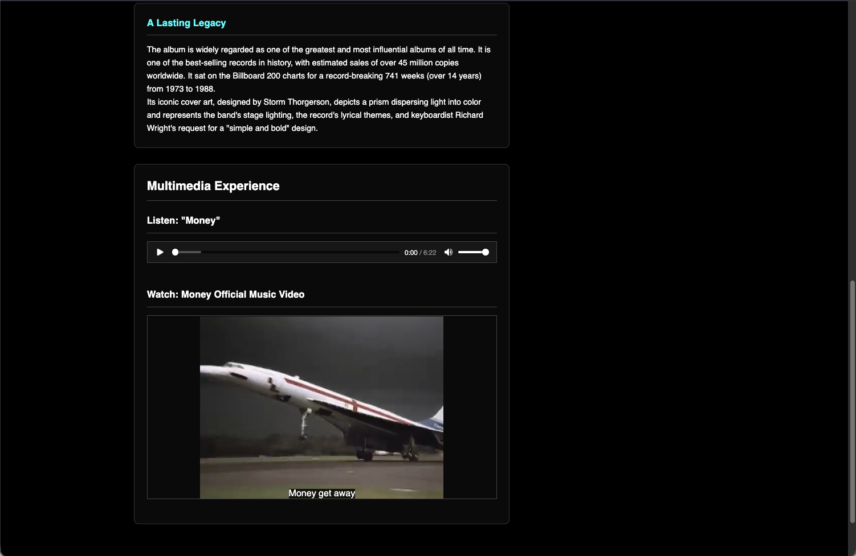

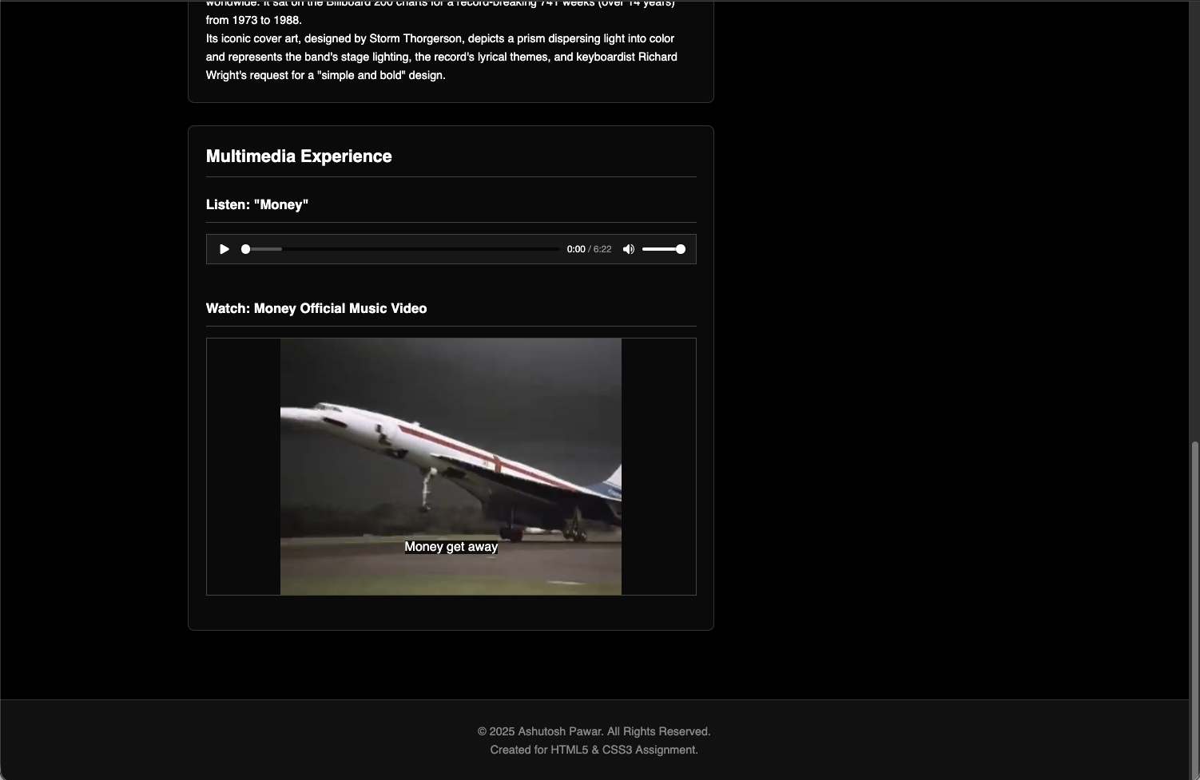

## **4. DECLARATION**

I hereby declare that this practical work entitled  
**“Design and Development of a Semantic and Multimedia Webpage Using HTML5”**is my original work carried out by **me**. This work has **not** been copied from any source and has not been submitted earlier for any examination.

**Name of Student:** Ashutosh Pawar  
**Roll Number :**  150096725130

**Signature of Student:** ASHUtosh paWAR  
**Date:** 16th January 2026

## **5. FUTURE SCOPE**

The current website is developed using only HTML5. The future enhancements that can be implemented are:

* Applying CSS for improved visual design and layout
* Adding interactivity using JavaScript
* Making the website fully responsive for all devices
* Hosting the website on a live server
* Adding forms and backend integration
* Enhancing accessibility using ARIA attributes